WEEK 4

SPRING REST using Spring Boot 3

**Hands on 1**

**Create a Spring Web Project using Maven**

CODE:

SpringLearnApplication.java

**package** com.cognizant.spring_learn;

**import** org.springframework.boot.SpringApplication;

**import** org.springframework.boot.autoconfigure.SpringBootApplication;

@SpringBootApplication

**public** **class** SpringLearnApplication {

**public** **static** **void** main(String[] args) {

System.***out***.println("START");

SpringApplication.*run*(SpringLearnApplication.**class**, args);

System.***out***.println("END");

}

}

OUTPUT:

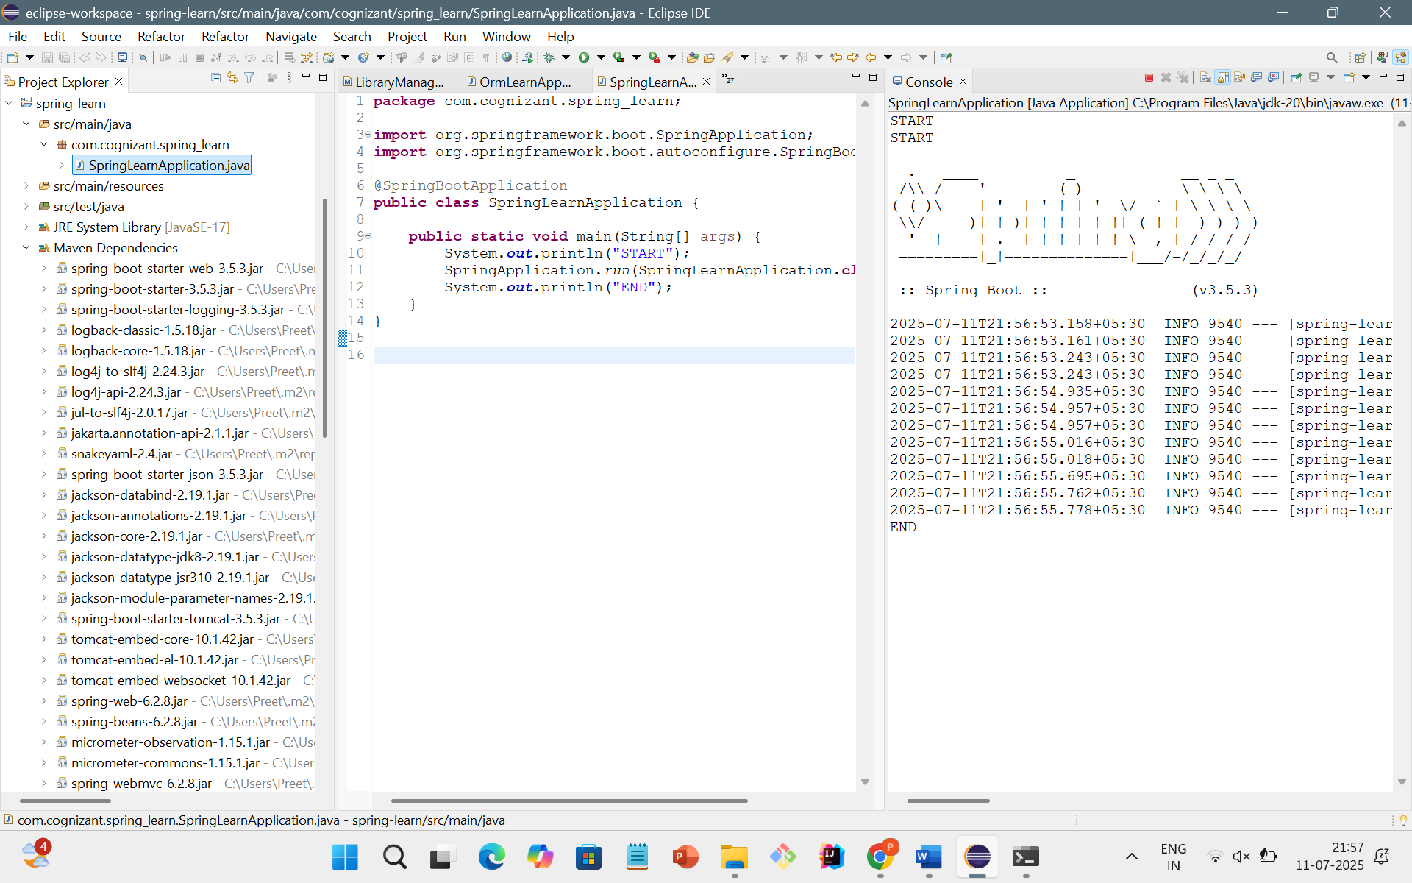

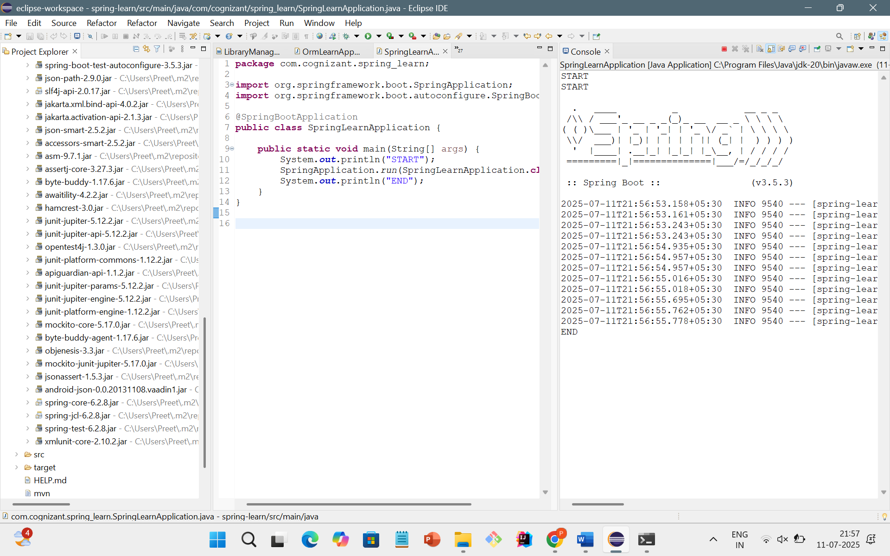

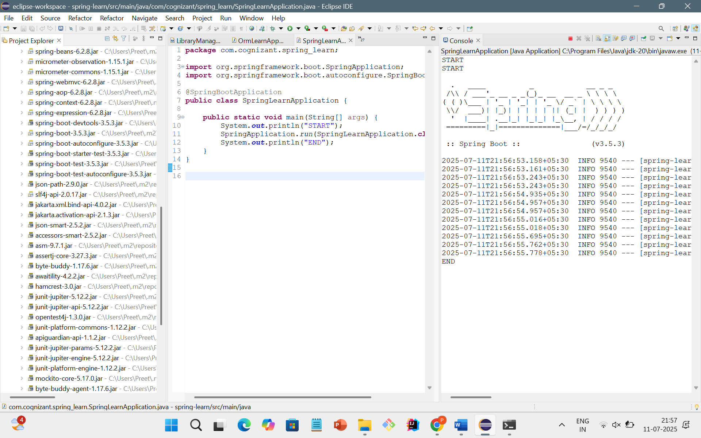

**Hands on 4**

**Spring Core – Load Country from Spring Configuration XML**

CODE:

Country.xml

<?xml version=*"1.0"* encoding=*"UTF-8"*?>

<beans xmlns=*"http://www.springframework.org/schema/beans"*

xmlns:xsi=*"http://www.w3.org/2001/XMLSchema-instance"*

xsi:schemaLocation=*"http://www.springframework.org/schema/beans https://www.springframework.org/schema/beans/spring-beans.xsd"*>

<bean id=*"country"* class=*"com.cognizant.spring_learn.Country"*>

<property name=*"code"* value=*"IN"*/>

<property name=*"name"* value=*"India"*/>

</bean>

</beans>

Country.java

**package** com.cognizant.spring_learn;

**public** **class** Country {

**private** String code;

**private** String name;

**public** Country() {

System.***out***.println("Inside Country Constructor.");

}

**public** String getCode() {

System.***out***.println("Inside getCode()");

**return** code;

}

**public** **void** setCode(String code) {

System.***out***.println("Inside setCode()");

**this**.code = code;

}

**public** String getName() {

System.***out***.println("Inside getName()");

**return** name;

}

**public** **void** setName(String name) {

System.***out***.println("Inside setName()");

**this**.name = name;

}

@Override

**public** String toString() {

**return** "Country [code=" + code + ", name=" + name + "]";

}

}

SpringlearnApplication.java

**package** com.cognizant.spring_learn;

**import** org.springframework.context.support.ClassPathXmlApplicationContext;

**public** **class** SpringLearnApplication {

**public** **static** **void** main(String[] args) {

System.***out***.println("START");

*displayCountry*();

System.***out***.println("END");

}

**public** **static** **void** displayCountry() {

**try** (ClassPathXmlApplicationContext context = **new** ClassPathXmlApplicationContext("country.xml")) {

Country country = context.getBean("country", Country.**class**);

System.***out***.println("Country: " + country);

}

}

}

OUTPUT:

